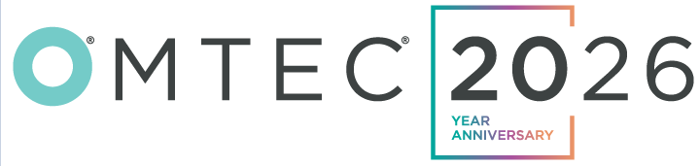
June 9-11 | Chicago

Get Approval for Your Trip to OMTEC in 3 Steps
- Identify your meeting objectives
Understanding your goals and those of the business can help you convince your superior. Cutting costs, automating your processes, sourcing new suppliers and technologies or staying ahead of upcoming trends are a few common examples.
- Learn more about OMTEC
Identify current and prospective partners you plan to meet. Review the education lineup and networking events that best align with your goals and consider how you can leverage these to return true, practical value to your organization.
- Send a formal request to your boss
The placeholders within the letter below are designed to give you the best chance for approval—be specific. Past attendees find great value in time savings (meeting with several partners in 1-3 days), growing their networking (meeting people who can solve problems and advance initiatives) and bolstering knowledge through an array of education offerings.

Dear [Supervisor Name],
I am interested in attending the 20th Annual Orthopaedic Manufacturing & Technology Exposition and Conference (OMTEC), which will take place June 9-11 in Chicago. The conference is widely known as the premier event for bringing OEMs and Suppliers together to tackle product development and supply chain challenges, as well as learn about cutting-edge innovations in orthopedic manufacturing technologies.
Over 200 orthopedic-focused suppliers will be exhibiting, affording me the opportunity to engage directly with key partners, including [NAME], [NAME] and [NAME]. These face-to-face meetings allow us to address ongoing challenges, explore new strategies and identify opportunities for greater efficiency in our operations.
Additionally, I’ll have the chance to connect with new suppliers and discover innovations in orthopedic manufacturing. Companies and technologies I plan to explore include [NAME/Technology], [NAME/Technology] and [NAME/Technology].
Here is my estimated cost breakdown for attending:
Conference Pass: $0 - $499 (special rates for early and group registrations)
Hotel: _______
Airfare: ________
Transportation: _________
Other (Meals, Per Diem, etc.): _________
Total Cost: _____________
When I return, I will prepare a post-event summary detailing our ROI.
Thank you for considering this proposal. I’m happy to discuss further why attending OMTEC will be a valuable investment for us.
Sincerely,

